Pool Opening Party
Saturday May 14
There will be a Fishing Derby at 2pm. Bring a fishing pole if you have one and bait. There will be a few fishing poles to borrow if you would like to participate but do not have a fishing pole. This event is for children 13 and under.
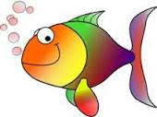
Rec Committee will supply the hamburgers, hot dogs, condiments and paper goods.

Grills Start at 3 pm and food will be served on a first come first serve basis.
Residents should bring their OWN beverage for their family and a dish to share. Last names beginning with A-G should bring a dessert or fruit and H-Z should bring a casserole or salad to share.

